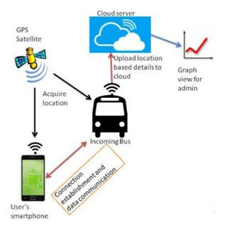

import pulp

# Define the problem as a linear programming problem

problem = pulp.LpProblem("PublicTransportOptimization", pulp.LpMinimize)

# Define variables: Whether to use each transportation option (binary variables)

bus = pulp.LpVariable("Bus", 0, 1, pulp.LpBinary)

subway = pulp.LpVariable("Subway", 0, 1, pulp.LpBinary)

walk = pulp.LpVariable("Walk", 0, 1, pulp.LpBinary)

# Define the objective function (e.g., minimize travel time or cost)

objective_function = 30 * bus + 20 * subway + 10 * walk # Adjust coefficients as needed

problem += objective_function

# Define constraints (e.g., total travel time, budget constraints)

problem += 2 * bus + 1 * subway + 0.5 * walk <= 8 # Total travel time constraint

problem += 3 * bus + 2 * subway + 0.2 * walk <= 15 # Budget constraint

# Solve the linear programming problem

problem.solve()

# Print the results

print("Bus:", bus.varValue)

print("Subway:", subway.varValue)

print("Walk:", walk.varValue)

# You can use the variable values to determine the optimized transportation choices.